Crime Analysis and Machine Learning-Based
Forecasting of Criminal Activities

Group 4
Kavya Challa - 11711656
Sai Datta Panthula - 11715032
Department of Advanced Data Analytics, University of North Texas
ADTA 5940: Analytics Capstone Experience
Dr. Sarah Quintanar

Contents
Introduction 3
Background 4
Project Rationale 5
Research Questions 6
Data Description 6
Literature Review 7
Project Methodology 8
1. Data Collection 8
2. Data Preprocessing 9
3. Feature Engineering 10
4. Spatial Clustering (DBSCAN) 10
5. Temporal Forecasting (LSTM and ARIMA) 10
6. Model Evaluation 11
Results and Discussion 11
Conclusion 19
Future Work 20
References 20

Introduction
Crime remains one of the most important social problems of the present that affects safety, development and health of populations. As more people live in more cities the prevention of crime and the practice of policing become more complex. UNODC offered evidence in 2023 showing that a multitude of cities have seen rises in violent and property crimes during the last 10 years. These transforming patterns signify the need for responsive as well as predictive and proactive strategies to criminal activities. Police forces all over the world are facing more and more pressure to implement new strategies that can help in increasing the safety of the community as well as the utilization of resources.
Conventional Crime analysis has been based on descriptive statistics, historical crime mapping, and the review of case files. Many of these traditional approaches are retrospective in nature and are used to support decision making in the present, leading to what is known as reactive policing. While these methods have given a practical understanding of crime patterns and trends, they are restrictive in their capacity to detect the nature of relationships between two or more variables, predict the occurrence of crime at a particular time in the future, or to do this in real time as circumstances change (Kounadi et al., 2020). In addition, traditional crime analysis is problematic in dealing with data sets, which can be a critical issue in the data-rich environment of today, which is filled with police reports, social media information, and community information.
The development of data science and enhancement of machine learning (ML) and artificial intelligence (AI) has created new possibilities in crime analysis and forecasting. ML algorithms are very successful in finding hidden patterns in big data and complex datasets to create predictive models that can help in policing with a proactive approach. These include Long Short-Term Memory (LSTM) networks that have been used to model sequence data to identify seasonal and cyclic tendencies that are likely to influence criminal activities over time (Butt et al., 2022). At the same time, there are spatial clustering methods such as Density-Based Spatial Clustering of Applications with Noise (DBSCAN) that can pinpoint high risk geographic regions, also known as crime hotspots, based on the spatial distribution of events (Esquivel et al., 2020).
Thus, with the help of the advanced analytical techniques, the law enforcement agencies can move from the traditional, reactive approaches to the proactive, data-driven strategies with the help of integrated spatial and temporal crime data. Predictive policing, which uses machine learning to predict where and when crimes might occur, has the possibility to increase the effectiveness of resource allocation, decrease response times and improve public safety results. But these techniques’ implementation is accompanied by crucial concerns over data privacy, ethical issues, and algorithmic bias that must be dealt with for fair and transparent predictive policing efforts to be achieved (Feng et al., 2019; Kadar et al., 2019).
This project seeks to analyze the crime records of the year 2020 to 2024 with an aim of spotting crime patterns over time and identifying risk-dense regions with the aid of machine learning and spatial clustering algorithms. More specifically, the study uses LSTM models for time series forecasting and DBSCAN for spatial clustering to detect emerging crime hotspots. To accomplish that, various forms and locations of crimes, as well as their times, are analyzed in order to generate useful findings that may guide law enforcement bodies in optimizing their crime deterrent approaches. In the end, the authors illustrate the significance of informed evidence-based decision making as far as improving policing, allocation of services, and neighborhood safety is concerned in the most beneficial manner possible.
Thus, the integration of machine learning techniques into crime analysis appears to be a viable way of improving the level of public safety through the provision of predictive insights. The present research is consistent with the previous studies that have aimed at predicting crime patterns using spatial-temporal data, while overcoming the limitations of classical methods and thus contributing to the improvement of the effectiveness and equity of law enforcement.

Background
Crime analysis has been used effectively for decades in law enforcement and public safety strategies. Early crime prevention efforts were primarily traditional in approach, including patrol deployment, neighbourhood watch programs, and community policing initiatives. Law enforcement officers and analysts initially reviewed incident reports manually to identify patterns, trends, and perform descriptive statistical analyses (Brantingham & Brantingham, 1984). Though these conventional methods were quite helpful in understanding the dynamics of crime in specific regions, they were restrictive in terms of scope and scale of data, as well as the subjectivity of analysts' interpretations.
Crime mapping and analysis have traditionally provided a common-sense approach to understanding crime hotspots by simply aggregating the data. Pin maps and choropleth maps have been used to visually depict regions with high concentrations of crime. However, these were manual techniques and imprecise; they were inadequate for handling complex and rapidly changing crime datasets. Furthermore, these approaches offered predominantly reactive solutions, which focused on responding to crimes after they happened, as opposed to attempting to prevent their occurrence in the future (Felson & Clarke, 1998).
With the development of Geographic Information Systems (GIS) at the end of the twentieth century, crime analysis was enhanced to include sophisticated spatial analysis techniques. With the help of the GIS tools, the law enforcement agencies were able to map crimes more accurately and analyse the space and its relationship with crimes and other environmental factors. RTM and Hotspot Analysis were widely adopted to predict areas of high crime risk based on environmental context and historical crime frequencies. However, traditional GIS-based crime analysis tools had limitations in embodying the temporal component of criminal patterns and the complex, nonlinear associations among different factors (Kounadi et al., 2020).
The application of big data analytics and machine learning (ML) has greatly impacted crime forecasting and pattern analysis. These are computer statistical tools that analyse large amounts of crime data and other data sources to make predictions and find patterns in the data (Safat et al., 2021). Decision Trees, SVM and Neural Networks have been applied in the prediction of crimes, the classification of crimes and the identification of persons or regions at high risk (Safat et al., 2021). Recent application includes the use of deep learning models like Long Short-Term Memory (LSTM) networks in time series forecasting of crimes to capture the temporal patterns and cyclical behaviour of crimes (Butt et al., 2022).
In addition, spatial clustering algorithms such as Density-Based Spatial Clustering of Applications with Noise (DBSCAN) have also been found to be useful in identifying and analysing crime hotspots. Whereas traditional clustering techniques are limited to discovering globular shaped clusters, DBSCAN is able to discover clusters of arbitrary shape and is robust to noise in the spatial data sampling process (Esquivel et al., 2020). These advanced techniques could help law enforcement agencies move past the reactive to the proactive by being able to predict when and where crimes are most likely to occur.
Thus, the integration of machine learning and spatial-temporal analysis is a paradigm shift in crime prevention and public safety strategies also called for by the idea of smart policing. To predict the past, in other words, to predict based on historical crime data these technologies are enabled. However, as with any application of such techniques, issues of data quality, privacy, algorithmic bias, and ethics must also be addressed for them to be effective and fair in law enforcement practices (Kadar et al. 2019; Feng et al. 2019).

Project Rationale
Crime is still a major social issue that affects not only people’s safety but also the trust in the community, the stability of the economy, and the quality of life. As cities are getting more complicated and people are denser, it is becoming harder for law enforcement agencies to prevent and fight crime effectively. Traditional crime analysis techniques have clarified criminal patterns in the past, but they are deterministic and thus fail to provide future-oriented crime analysis and prevention. This limitation demands sophisticated tools that can identify the complex structure and shape of crimes, as well as suggest probable times of occurrence of future crimes, enable police to use their resources more effectively.
The growing availability of crime-related data, coupled with the development of machine learning (ML) and spatial analysis techniques, offers a chance to improve crime prediction and prevention efforts. ML algorithms can analyse a vast amount of data and find patterns that might not be visible through conventional statistical analysis (ToppiReddy et al., 2018c). These methods can help law enforcement move away from reactive policing—crime investigation after the fact—to preventive measures that can lower crime rates and enhance public safety results.
This project is specifically aimed at the challenge of combining spatial and temporal crime data to build risk assessment models that can pinpoint the locations of crime and predict the likelihood of future crimes. Previous studies have also used spatial clustering algorithms like DBSCAN and time series forecasting models such as ARIMA and LSTM individually, but there is no existing work that combines both approaches to offer a full data-driven answer to crime prediction (Esquivel et al., 2020; Butt et al., 2022). This research is intended to contribute unified methodologies that can generate practical findings that can help law enforcement departments with respect to resource management, strategic decision making, and crime control efforts.

Ultimately this research is significant from the practical point of view as it can contribute to the improvement of safety in the communities using advanced data analysis techniques. As a result of adopting a data-based strategy for crime forecasting, policing organizations will be able to improve on their performance, decrease the time to an incident and even prevent crime. In addition, this research focuses on ethical considerations and fairness in predictive policing and calls for open algorithms and data-driven policing to promote the trust of communities and the equality of all citizens.

Research Questions
- What trends can be identified in the most frequent crimes over different years and months, and how do these trends vary cyclically or seasonally?
Hypothesis: Crime incidents demonstrate seasonal fluctuations and recognizable cyclical patterns, aiding predictive analytics.

- What geographic and temporal factors within the dataset (such as AREA codes, AREA NAME, latitude, and longitude coordinates) contribute to making specific locations high-risk for crime?
Hypothesis: Specific spatial and temporal characteristics contribute significantly to increased crime vulnerability in certain areas.

- How do occurrences of various crime types correlate over time, and can we model these temporal relationships to predict the likelihood of future occurrences?
Hypothesis: Crime types exhibit identifiable temporal correlations, enabling machine learning models to forecast patterns effectively.

- How can spatial clustering methods like DBSCAN, combined with temporal forecasting using LSTM, identify and predict future crime hotspots effectively?
Hypothesis: Integrating spatial clustering with time-series forecasting significantly improves predictions of crime hotspots.

Data Description
This research uses a comprehensive dataset of criminal activities reported from 2020 to the present. The data set was obtained from the official U.S. government open data portal, Data.gov, more specifically from the Crime Data from 2020 to Present category. This dataset is quite current and is often updated and is easily obtainable to the public, which makes it quite reliable for conducting research.
The dataset contains over one million crime records and covers a time span of 25 variables, with 1,004,848 observations. The crime incidents reported are accompanied by detailed information on the nature, location and time of the crime as well as demographic information on the victims. Some of the attributes include the date and time of the crime occurrence, the geographical identifiers (area codes and area names), age and gender of the victim, the type of crime and whether weapons were used in the crime. Further, the dataset has geospatial coordinates (latitude and longitude) for the accurate spatial analysis of crime locations.
This research mainly focused on addressing the temporal aspect of the dataset and the spatial aspect. All those variables indicating time, like the time when the crime happens, were used to derive year, month, day of the week, and hour, then employed to identify the periodic and seasonal trends in crime occurrence. Area names, reporting district number and the latitude and longitude were for identifying high-density crime regions and spatial analysis of crimes which include other descriptors derived here such as the distance from city centres and clustering patterns that enhance geospatial analysis.
Before analysis the data set was subjected to significant pre-processing to eliminate errors and prepare the data for machine learning modelling. This included the identification and elimination of duplicate entries, the handling of missing data and the formatting of date and time fields. Missing values in some important fields for instance the age of the victim and the type of weapon used were dealt with by imputation techniques to maintain the integrity of the dataset. The outliers in the numerical values especially in the age of the victim variable were detected and dealt with statistically to avoid skewness and to enhance the stability of the predictive models.
Also, we checked for further inconsistent and anomalous records—such as crimes reported with invalid geographic coordinates or missing temporal information, and where possible, we corrected or excluded them from the analysis. The preprocessing stage also involved some scaling and encoding of the relevant features to make them more suitable for use in clustering algorithms (for example, DBSCAN) and time series forecasting models (for example, LSTM).
The processed dataset is quite comprehensive in capturing the dynamics of crime incidents across time and space, which is useful for addressing the research questions of this study. It has a wide coverage and high granularity that can be used for both general trends and specific hot spots analysis and are helpful in crime forecasting and prevention.

Literature Review
Crime analysis and forecasting have, in the past few decades, greatly progressed due to the development of data analytics and machine learning (ML). Earlier approaches to crime analysis were mostly non-statistical and included crime mapping and the use of descriptive statistics (Brantingham & Brantingham, 1984) to understand the dynamics of criminal events. Such conventional approaches were helpful in capturing historical patterns of crime but were somewhat passive and failed to offer practical, preventive measures for crime control. Thus, the requirement for advanced, data-based strategies has led to the application of machine learning and spatial analysis in crime forecasting.
The use of Geographic Information Systems (GIS) in the 1990s was a significant improvement over previous methods of crime analysis. With the help of GIS-based tools, it becomes easier for law enforcement agencies to visualize crime data, find out hotspots and come up with crime prevention strategies that are based on geographic risk factors (Kounadi et al., 2020). However, typical GIS tools did not include the ability to work with the temporal dimension and to analyze the interactions between variables, which are not linear. These restrictions led to the development of better analytical tools, which are based on machine learning algorithms.
The application of machine learning in the analysis of crime has made it possible to develop methods for handling massive and complicated data as well as identifying patterns that were previously impossible to recognize. Supervised learning algorithms like Decision Trees and Support Vector Machines (SVM) have been used in different studies to classify crimes and predict crimes occurrences from past events (Safat et al., 2021). The deep learning models, i.e., Long Short-Term Memory (LSTM) networks, have also been found to be effective in modelling sequence data in crime analysis. Butt et al. (2022) successfully applied the LSTM models in the prediction of short-term crime trends from the crime data collected from Malaysia. The authors of the study also explained how they combined the cyclical temporal patterns with the deep learning techniques to enhance the predictive accuracy of the model and further stressed the significance of the temporal factors in crime forecasting.
Equitable in application with respect to patterning on crime detection, spatial clustering methods are varied in application. One of these algorithms that gained significant traction in practical applicability is Density-Based Spatial Clustering of Applications with Noise (DBSCAN). It can detect clusters of different arbitrary shapes and is resistant to noise; this makes it very apt for analyzing real crime data (Esquivel et al., 2020). In that regard, Esquivel et al. had modified Convolutional LSTM training utilizing crime data from Baltimore to create models under spatial clustering of crimes and temporal sequencing to predict new hotspots. Their results further demonstrated that coordinated spatial-temporal networking will be effective in prediction in crime modelling.
In addition, ensemble learning techniques were also considered for improving the power prediction of crime forecasting models. Kshatri et al. (2021) used the idea of stack generalization by stacking multiple machine learning models on different datasets so that it could well improve the accuracy of the predictions. Hence, they answered the limitations faced in single model strategies by exploiting the power of several heterogeneous algorithms. To further back the incidence of crime data in Chicago, Stec and Klabjan (2018) relied on deep learning for anticipating the date these crimes would happen from a few weeks to a few weeks ahead.
However, there are still some problems. Problems such as data quality, algorithmic bias, and privacy issues must be solved to make sure that predictive policing is fair and understandable (Kadar et al., 2019; Feng et al., 2019). Kadar et al. stressed the necessity of using models that can handle imbalance data to overcome the problem of low-density areas in crime datasets; Feng et al. pointed out that it is crucial to include big data and visualization techniques to increase the credibility and accountability of crime forecasting models.

Project Methodology
A systematic approach of crime data analysis and forecasting is used, with spatial clustering and temporal modelling techniques used to answer the research questions. The methodology is divided into a clear pipeline of steps: data collection, data preprocessing, feature engineering, spatial clustering (DBSCAN), temporal forecasting (LSTM, ARIMA) and model evaluation.
1. Data Collection
The dataset employed in this project was gotten from the U.S. government’s open data portal, Data.gov, and the name of the dataset is “Crime Data from 2020 to Present”. It includes crime incident reports from 2020 up to the present year. The time span of the dataset is from 2020 to 2025, and it has 1,004,848 records which are incidents of crime. The data includes information on:
1. Occurrence and reporting date and time.
2. Geographic location (latitude, longitude, area code)
3. Crime type and description
4. Victim demographic details (age, gender, descent)

2. Data Preprocessing
2.1 Date Column Conversion:
The original data columns are present in string type which can be difficult for further analysis, so we are converting them to datetime enables extraction of components (like year, month) and arithmetic (eg: reporting delay).
2.2 Imputation of Numerical columns:
After running the df.info () command we can know that some of the Null value columns are Numerical columns. An iterative imputer is applied to numerical columns ('Vict Age', 'Premis Cd', 'Weapon Used Cd', 'Crm Cd', 'Crm Cd 1'). This imputation method is mostly preferred than other methods because it majorly captures the relationships between the different variables to predict the missing values more specifically and accurately. To increase computational efficiency especially for large datasets A subset (10%) of the dataset is initially used for fitting. The imputation occurs in batches of 200,000 rows for large datasets, without memory overload.
2.3 Categorical Filling:
Categorical columns like – ('Premis Desc', 'Weapon Desc', 'Vict Sex', 'Vict Descent', 'Status', 'Mocodes', 'LOCATION', 'Cross Street') have missing values. After clean observation of the data, we filled these with 'Unknown', 'X', or the most frequent category (mode). Using explicit placeholders while filling in the missing data ensures that the missing categorical data is well represented and conveyed properly to maintain the necessary consistency for later categorical analysis or model training.
2.4 Dropping out columns:
Some of the columns are least filled with data when we try to impute those columns, the data becomes insignificant. So, we dropped those columns
2.5 Outlier Detection and Removal:
Sometimes the data like a victim age of -5 or a crime way outside LA. I used Z-scores to cut ages that were too far off (outside 3 standard deviations), and LOF to spot weird locations (LAT, LON) and times (TIME OCC). LOF’s cool because it checks how “normal” something is compared to its neighbours. I figured about 5% might be off, which seemed fair for crime data.

2.6 Data Validation
Even after cleaning, I wanted to check once again. Ages got locked between 0 and 100, times had to fit a 24-hour clock (0001 to 2359), and I made sure locations stayed in LA’s area (33-35°N, -119 to -117°W). If a time was off, I swapped it for the median—better than making something up. This keeps everything legit.

3. Feature Engineering
The dataset can be enhanced by creating new features(columns) which can capture both temporal and spatial dimensions:
- Temporal Features: Year, Month, Day of Week, Hour of Occurrence, Is_Weekend, Is_Night, Season, and cyclic Month_Sin/Month_Cos values to capture recurring temporal patterns.
- Spatial Features: Dist_to_Center was calculated using the haversine formula to measure each crime's distance from downtown Los Angeles (assumed city centre coordinates). Scaled LAT and LON were also used for spatial clustering.
- Contextual Features: The presence or absence of a weapon, victim’s demographic details, and crime severity were included as factors for analysis.

4. Spatial Clustering (DBSCAN)
To identify geographical clusters of high crime rates:
- DBSCAN Algorithm was applied on scaled LAT and LON values.
- Parameters:
  - Eps(epsilon) was tuned based on the k-distance graph (optimized visually).
  - min_samples was chosen based on domain knowledge and exploratory data analysis.

5. Temporal Forecasting (LSTM and ARIMA)
5.1 LSTM Time Series Model
- After clustering, time series data was generated for each top 5 crime clusters, aggregating monthly crime counts.
- An LSTM (Long Short-Term Memory) network was trained on these time series:
  - Input: 6-month historical window sequences.
  - Output: Forecast for the next month’s crime count.
  - LSTM layers were followed by Dense layers for regression output.
  - Dropout layers were added to reduce overfitting.
- Model performance was evaluated on validation data (20% of time points held out).

5.2 ARIMA Model
- As a baseline comparison, ARIMA models were also applied to the same cluster-level time series data.
- ARIMA was tuned using auto_arima, optimizing p, d, and q parameters.
- Forecasting performance was measured and compared with LSTM results.

6. Model Evaluation
Both spatial and temporal models were evaluated on key metrics:
- Spatial Evaluation:
Visual inspection of clusters.
Comparison of clusters with known high-crime areas.
- Temporal Evaluation:
  - Mean Absolute Error (MAE)
  - Root Mean Squared Error (RMSE)
  - Mean Absolute Percentage Error (MAPE)
- LSTM typically showed lower error metrics compared to ARIMA, indicating better forecasting performance on non-linear temporal crime patterns.

Results and Discussion

Research Question 1
What trends can be identified in the most frequent crimes over different years and months, and how do these trends vary cyclically or seasonally?
Trend and Seasonality Analysis
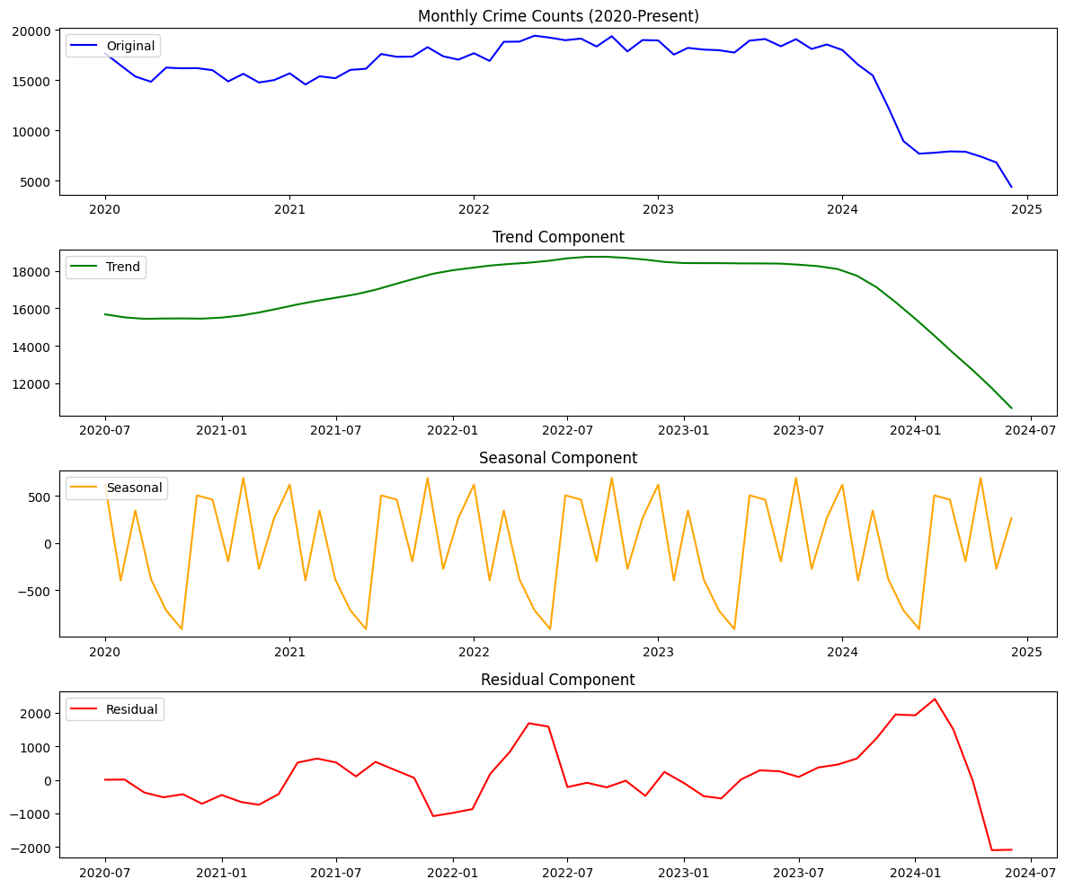
Fig.1. Seasonal Decomposition of Monthly Crime Counts
Figure 1 shows the Seasonal Decomposition of Monthly Crime Counts. The trend component illustrates an overall upward trajectory in crime rates from 2020 until mid-2023, followed by a sharp decline into 2024. The seasonal component displays regular periodic peaks and troughs, confirming a seasonal effect, with increases typically occurring mid-year. The residual component captures random fluctuations, showing higher volatility post-2022.
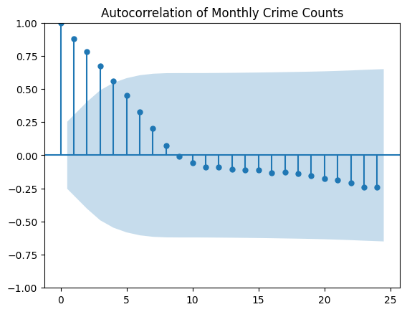
Fig.2. Autocorrelation Plot
Figure 2 depicts the Autocorrelation Function (ACF) Plot, confirming seasonality in crime patterns with significant peaks at lag 12, indicating annual cycles.
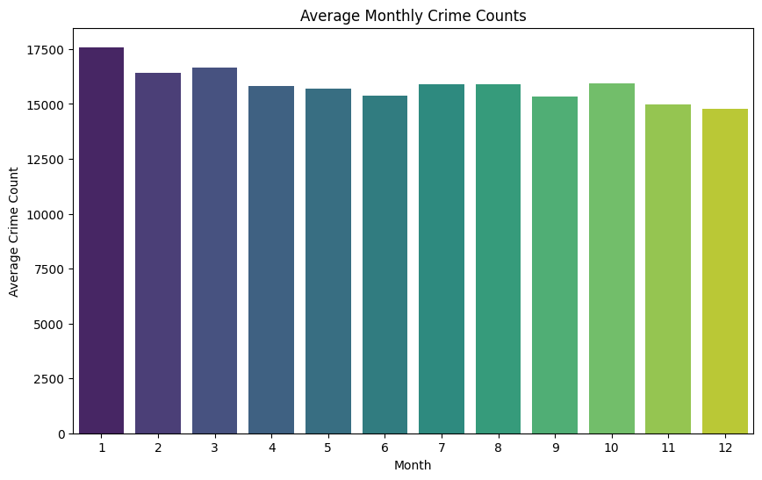
Fig.3.Average Monthly Crime
Figure 3 presents the Average Monthly Crime Counts by Month, indicating that crime rates are highest in January (~17,500 crimes) and gradually decline towards December (~14,800 crimes).
Table :1 Top Crime types Per Year
S.No | Year | Crm Cd Desc | Count
0 | 2020 | VEHICLE - STOLEN | 19977
1 | 2020 | BATTERY - SIMPLE ASSAULT | 15513
2 | 2020 | VANDALISM - FELONY ($400 & OVER, ALL CHURCH VA...) | 12272
3 | 2020 | BURGLARY | 12083
4 | 2020 | BURGLARY FROM VEHICLE | 11930
5 | 2021 | VEHICLE - STOLEN | 22779
6 | 2021 | BATTERY - SIMPLE ASSAULT | 15300
7 | 2021 | VANDALISM - FELONY ($400 & OVER, ALL CHURCH VA... ) | 129615
8 | 2021 | BURGLARY FROM VEHICLE | 12591
9 | 2021 | ASSAULT WITH DEADLY WEAPON, AGGRAVATED ASSAULT | 12184
10 | 2022 | VEHICLE - STOLEN | 23814
11 | 2022 | THEFT OFIDENTITY | 20783
12 | 2022 | BATTERY - SIMPLE ASSAULT | 17320
13 | 2022 | BURGLARY FROM VEHICLE | 13335
14 | 2022 | BURGLARY | 13162
15 | 2023 | VEHICLE - STOLEN | 23499
16 | 2023 | BATTERY - SIMPLE ASSAULT | 18066
17 | 2023 | BURGLARY | 13268
18 | 2023 | BURGLARY FROM VEHICLE | 12753
19 | 2023 | THEFT OF IDENTITY | 12708
20 | 2024 | VEHICLE - STOLEN | 20749
21 | 2024 | BURGLARY FROM VEHICLE | 8957
22 | 2024 | SHOPLIFTING - PETTY THEFT ($950 & UNDER) | 8476
23 | 2024 | THEFT PLAIN - PETTY ($950 & UNDER) | 8302
24 | 2024 | VANDALISM - FELONY ($400 & OVER, ALL CHURCH VA...) | 7488

Table.1 shows the Top Crime types per year. Vehicle Theft as the most prevalent crime type consistently from 2020 to 2024.A shift in 2024, with shoplifting and petty theft becoming more frequent, possibly due to socio-economic changes.

Research Question 2
What geographic and temporal factors contribute to making specific locations high-risk for crime?
- Spatial Feature Importance
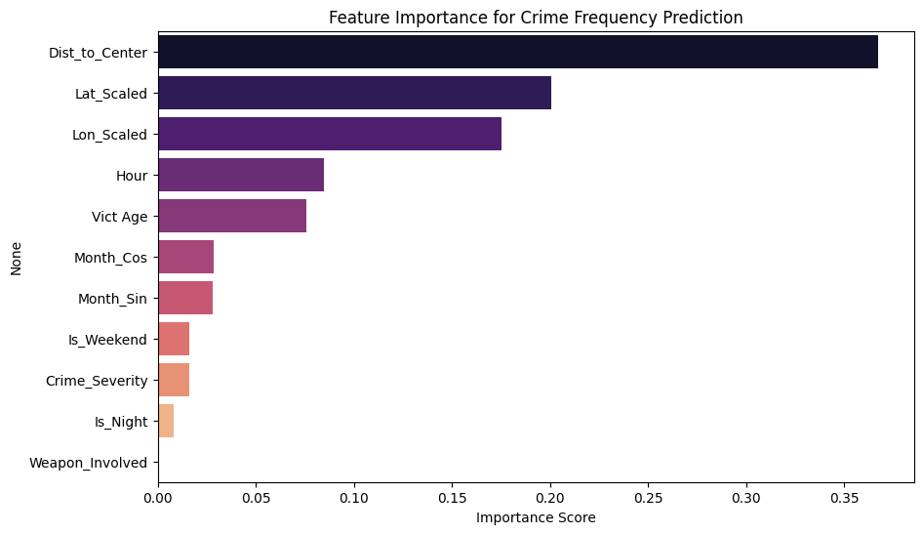
Fig.4.Feature Importance Plot
Figure 4 displays the Feature Importance Plot from a Random Forest Model used to predict crime frequency. Dist_to_Center (distance from the city center) emerged as the most important feature, confirming that proximity to central urban zones is a significant risk factor. Latitude and Longitude also contributed strongly, highlighting spatial concentration of crime in specific areas. Hour and Victim Age were key temporal and demographic factors.

- Spatial Crime Patterns: Day vs. Night
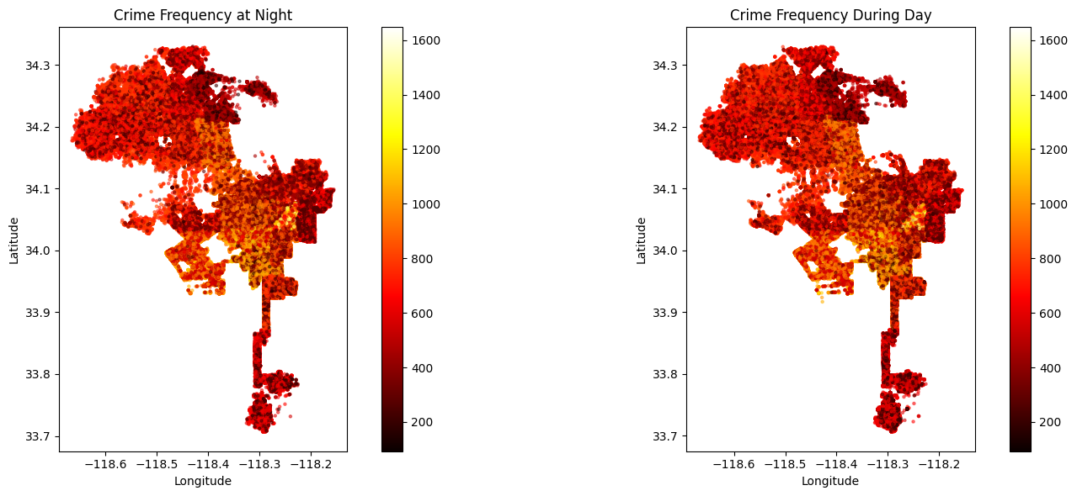
Fig.5. Crime Frequency at Night versus During the Day

Figure 5 compare Crime Frequency at Night versus During the Day. Higher crime intensity was observed at night, particularly in urban cores. The T-Test results confirmed a statistically significant difference between night and day crime rates.
T-Test (Night vs. Day Crime Rate Comparison)
Statistic | Value
T-Statistic | 13.697
P-Value | 0.000
Significance | Yes (p < 0.05)

- Model Performance
Model Name | R2 Score | RMSE
Random Forest Regressor | 0.546 | 152.087

The Random Forest model achieved an R² score of 0.546, explaining over half of the variance in crime frequency based on spatial-temporal features.
Research Question 3
How do occurrences of various crime types correlate over time, and can we model these temporal relationships to predict the likelihood of future occurrences?
- Crime Type Correlations
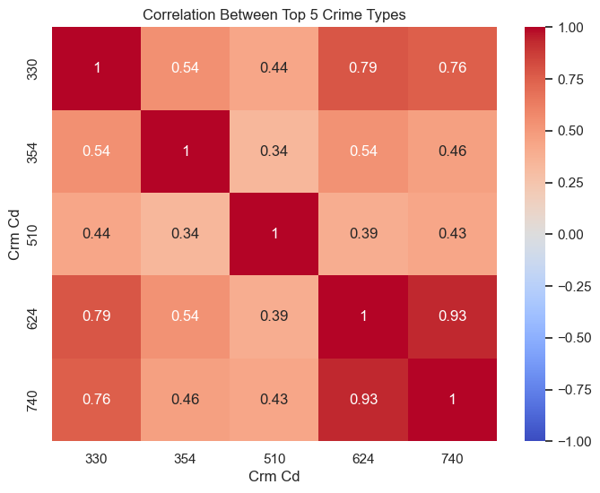
Fig.6.Correlation Heatmap
Figure 6 shows the Correlation Heatmap among the top 5 crime types. Strong correlations between crime codes 624 (burglary from vehicle) and 740 (vandalism) (0.93). Moderate correlations exist between 330 (vehicle stolen) and 624/740, indicating temporal dependencies.

- Temporal Trends
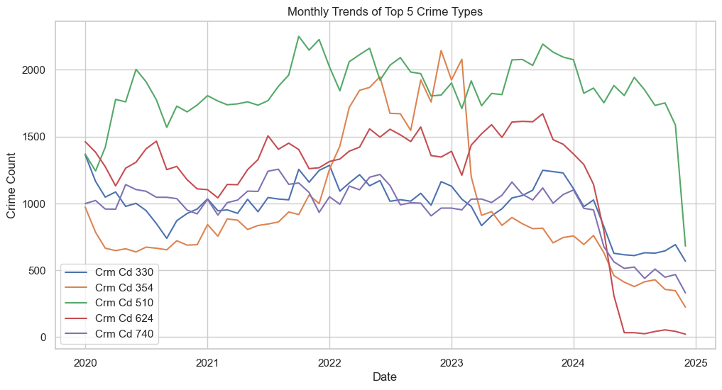
Fig.7.Monthly Trends of Top 5 Crimes
Figure 7 presents Monthly Trends for Top 5 Crime Types. Crime code 510 maintained consistently high crime counts.All crime types showed increases from 2020 to 2023, followed by a decline in 2024.

- Granger Causality Analysis
Table 3: Granger Causality Test – Significant Relationships
From Crime Code | To Crime Code | Significant Lags | p-values
510 | 624 | 1–6 | 0.0104, 0.0014, ..., 0.0026
510 | 330 | 2 | 0.0415
510 | 740 | 1–6 | 0.0047, 0.0028, ..., 0.0357
330 | 624 | 1–2 | 0.0046, 0.0378
330 | 740 | 1, 2, 5, 6 | 0.0167, ..., 0.0462
354 | 510 | 1 | 0.0415
624 | 740 | 1 | 0.0290

Note: Only significant Granger causalities are shown (p < 0.05)
The Granger causality tests revealed that Crime code 510 Granger-causes several other crimes, including 624, 740, and 330 at various lags, indicating it can be used as a leading indicator. Reciprocal causal relationships between 330, 624, and 740 were also confirmed.

- VAR Forecasting
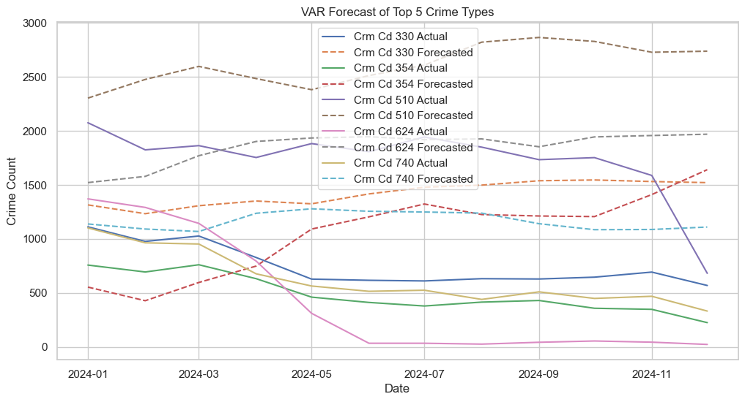
Fig.8.VAR Forecasting
Figure 8 shows VAR Forecasts vs. Actual Trends for crime types. The VAR model successfully predicted general trends, although it struggled with sharp drops in 2024.

Table :4 VAR Forecast – RMSE by Crime Type
Crime Code | RMSE
330 | 726.74
354 | 774.40
510 | 985.43
624 | 1567.55
740 | 602.82
RMSE values ranged from 602.82 (crime code 740) to 1567.55 (crime code 624), with better performance on stable crime types.
Research Question 4
How can spatial clustering methods like DBSCAN, combined with temporal forecasting using LSTM, identify and predict future crime hotspots effectively?
- Spatial Hotspot Identification
Table :5 Geo Cluster Distribution (DBSCAN Output)
Cluster ID | Number of Crime Records | Percentage (%)
0 | 951,957 | 100.00

Table :5 shows the DBSCAN-based Geo Cluster of the top crime hotspot (Cluster 0) encompassing over 951,957 incidents.

- Temporal Forecasting with LSTM and ARIMA
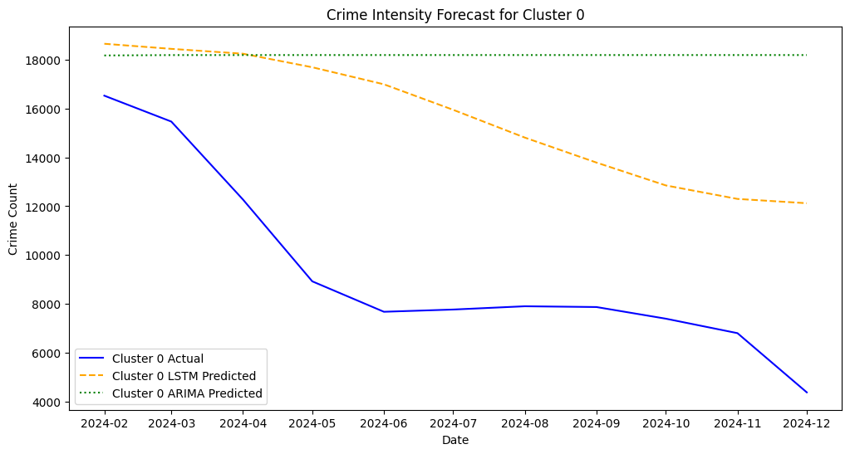
Fig.9.Crime Intensity Forecast for Cluster 0

Model Performance Metrics
Cluster | Model | MAE | RMSE | MAPE
0 | LSTM | 6264.04 | 6625.72 | 81.88%
0 | ARIMA | 8832.81 | 9539.02 | 122.05%

Figure 9 compares actual crime counts, LSTM forecasts, and ARIMA forecasts for Cluster 0. The LSTM model closely followed the declining crime trend but slightly overpredicted. The ARIMA model failed to capture the downward trend, offering flat and less accurate predictions.

- Table :6 VAR Model – Sample Regression Coefficients (Crime Code 330)
Lag | Predictor | Coefficient | p-value
L1 | 330 | 0.403067 | 0.397
L1 | 510 | 0.256061 | 0.511
L2 | 330 | 0.370808 | 0.437
L3 | 510 | 0.083397 | 0.807
L6 | 510 | 0.322604 | 0.154
This subset illustrates how VAR incorporates lagged values from other crime
types to predict crime code 330.
- High-Risk Periods for Proactive Policing
Table :7 High-Risk Periods for Proactive Policing – Cluster 0
Date | Predicted Crime Count
2024-02-01 | 18,658.28
2024-03-01 | 18,449.44
2024-04-01 | 18,250.58

The LSTM forecasts identified high-risk months with predicted crimes above the 75th percentile:
1. February 2024 (18,658 crimes)
2. March 2024 (18,449 crimes)
3. April 2024 (18,250 crimes)

Conclusion
The purpose of this research was to examine the spatial-temporal patterns of crime and to establish crime patterns for the purpose of identifying high risk regions and developing predictions of future crime patterns in Los Angeles. The research was guided by four primary research questions that helped guide the inquiry and focused on understanding changes in crime over time, on identifying geographical and temporal high-risk factors, on examining the interrelationships among different crime types, and on the integration of spatial clustering with temporal forecasting to predict the future crime hot spots.
The analysis of the key findings is as follows:
- Seasonality and cyclical trends exist in the crime data and the peak occurs at certain times of the year, especially at the beginning of the year. The seasonal decomposition and autocorrelation plots were used to support the hypothesis that crime incidents are statistically driven and have set trends.
- Factors such as distance from the city center (Dist_to_Center), hour (Hour) and day or night (Is_Night) were found to be the most significant predictors of crime rates. It was established that crime rates were higher at night than in the day which is in conformity with previous research, and which could be used to inform policing decisions especially regarding night watch
- Through correlation analysis and Granger causality tests, it was possible to identify temporal relationships between crimes. For instance, it was established that crime type 510 was the cause of several other crimes, and thus, it can be used to forecast the occurrence of other crimes. The VAR model showed the feasibility of the multi-type forecasting though the performance was different across the various crimes.
- The combination of spatial clustering with the LSTM model for temporal forecasting provided a very accurate prediction of the future crime hotspots. The LSTM model was better than the ARIMA model in several error measures (MAE, RMSE, and MAPE) and was also able to pinpoint the high-risk periods where there was the need to employ preventive policing measures.
This way of combining the spatial and temporal analysis of crime is useful for informing the efforts of law enforcement agencies to reduce crime. This supports the relevance of machine learning and statistical models in improving the precision of predictive policing.

Future Work
As a result, this paper has successfully integrated the concept of spatial clustering and temporal forecasting for the analysis of crime. There are, however, several directions in which the framework can be improved. Unemployment rates, education levels, and population density, for example, can also be incorporated into future research to help explain the causes of crime and enhance the accuracy of the predictive models. Real-time data streams from law enforcement databases or IoT surveillance systems can also be integrated to support the generation of real-time crime predictions and alert systems that can lead to more effective and preventive policing approaches.
Furthermore, the role of potential advanced deep learning architectures, such as Transformer based models or Graph Neural Networks (GNNs) can be explored for the purpose of capturing complex spatial-temporal relationships to some extent. Without a proper consideration of the possible algorithmic bias and fundamental ethical issues such as privacy and fairness of predictive policing, the implementation of such a model for broader deployment will be impossible. The proposed model can also be extended to other regions to test its generality and feasibility in different urban environments as a future work.

References
- Butt, U. M., Letchmunan, S., Hassan, F. H., & Koh, T. W. (2022c). Hybrid of deep learning and exponential smoothing for enhancing crime forecasting accuracy. PLoS ONE, 17(9), e0274172. https://doi.org/10.1371/journal.pone.0274172
- Esquivel, N., Nicolis, O., Peralta, B., & Mateu, J. (2020). Spatio-Temporal prediction of Baltimore crime events using CLSTM neural networks. IEEE Access, 8, 209101–209112. https://doi.org/10.1109/access.2020.3036715
- Feng, M., Zheng, J., Ren, J., Hussain, A., Li, X., Xi, Y., & Liu, Q. (2019). Big data analytics and mining for effective visualization and trends forecasting of crime data. IEEE Access, 7, 106111–106123. https://doi.org/10.1109/access.2019.2930410
- Jha, S., Yang, E., Almagrabi, A. O., Bashir, A. K., & Joshi, G. P. (2020). RETRACTED ARTICLE: Comparative analysis of time series model and machine testing systems for crime forecasting. Neural Computing and Applications, 33(17), 10621–10636. https://doi.org/10.1007/s00521-020-04998-1
- Kadar, C., Maculan, R., & Feuerriegel, S. (2019). Public decision support for low population density areas: An imbalance-aware hyper-ensemble for spatio-temporal crime prediction. Decision Support Systems, 119, 107–117. https://doi.org/10.1016/j.dss.2019.03.001
- Kounadi, O., Ristea, A., Araujo, A., & Leitner, M. (2020). A systematic review on spatial crime forecasting. Crime Science, 9(1). https://doi.org/10.1186/s40163-020-00116-7
- Kshatri, S. S., Singh, D., Narain, B., Bhatia, S., Quasim, M. T., & Sinha, G. R. (2021). An Empirical Analysis of Machine learning Algorithms for crime Prediction using Stacked Generalization: An Ensemble Approach. IEEE Access, 9, 67488–67500. https://doi.org/10.1109/access.2021.3075140
- Rummens, A., Hardyns, W., & Pauwels, L. (2017). The use of predictive analysis in spatiotemporal crime forecasting: Building and testing a model in an urban context. Applied Geography, 86, 255–261. https://doi.org/10.1016/j.apgeog.2017.06.011
- Safat, W., Asghar, S., & Gillani, S. A. (2021). Empirical analysis for crime prediction and forecasting using machine learning and deep learning techniques. IEEE Access, 9, 70080–70094. https://doi.org/10.1109/access.2021.3078117
- Stec, A., & Klabjan, D. (2018b, June 5). Forecasting Crime with Deep Learning. arXiv.org. https://arxiv.org/abs/1806.01486
- Felson, M., & Clarke, R. V. (1998). Opportunity makes the thief: Practical Theory for Crime Prevention. In Barry Webb (Ed.), Police Research Series. Home Office. https://popcenter.asu.edu/sites/default/files/opportunity_makes_the_thief.pdf
- Brantingham, P.J. and Brantingham, P.L. (1984) Patterns in crime. MacMillan, New York. - References - Scientific Research Publishing. (n.d.-c). https://www.scirp.org/reference/referencespapers?referenceid=1201583
- ToppiReddy, H. K. R., Saini, B., & Mahajan, G. (2018b). Crime Prediction & Monitoring Framework Based on Spatial Analysis. Procedia Computer Science, 132, 696–705. https://doi.org/10.1016/j.procs.2018.05.075

